Little SPARK: Simple Play Adaptations to Reference for Kids

Hi Ho Cherry-O Built-In Switch Game
Description: | Image:
This counting game includes a game board equipped with two switch plates and two external jacks to accommodate external switches, such as Buddy Buttons, available for loan.  Purchasing Information  User’s Manual | 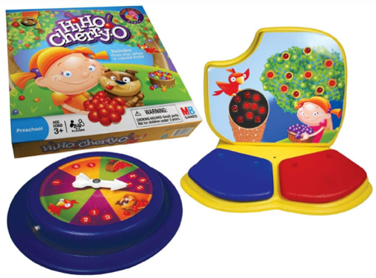

Who Might Benefit?
Those who benefit from engaging, accessible activities that use simple cause-and-effect mechanisms—such as switch-activated spinners or lights—to support motor skill development, attention, peer interaction, and foundational math concepts, while accommodating fine motor, mobility, and visual challenges.
Why Use?
Provides an opportunity for multi-sensory, switch-accessible experiences that promote color recognition, counting, hand-eye coordination, problem-solving, one-to-one correspondence, and cooperative play, making learning engaging and inclusive for diverse learners.
Instructions for Use: | Adaptation Ideas:
Environmental Considerations  - Use in any environment including community, home, and school on a flat surface.  Positioning  - Use in seated position at a table or on the floor, standing at a table, or lying on the floor.  Basic Play/Use  - Each player begins with a “tree” on the game board, players take turns, the first player to empty their tree and/or fill their basket wins the game.  Alternate Positioning  - Place spinner on tilted surface such as a 3-ring binder and stabilize with Dycem, shelf-liner, or Velcro for easy viewing.  Extended Play/Use  - Replace the picture of cherries with numbers, or use a bigger game surface using large pieces of construction paper to depict game pieces.  Play/Use with Others  - Encourage the player to count together, model turn taking or develop a script for turn taking. | Build It Up  - Enlarge switch surface with foam board.  Stabilize It  - Encourage the child to rest their forearm on the table while engaged in the activity.  - Use Dycem under the item or attach Velcro.  Simplify It  - Reduce the number of cherries needed to win the game.  - Encourage addition and subtraction skills using a number line from 1-10.  Add Sensory Cues  - Apply various textures (e.g. Velcro, Dycem, shelf liner) to switch surfaces to add tactile interest.  Communication Support  - Develop social scripts for turn taking.  Alternative Uses  - Record the phrase on a voice output device for anyone unable to say the words when they win.  - Trial different switches.
Words to Encourage Play/Use
Your turn   |   My Turn | Done  
More  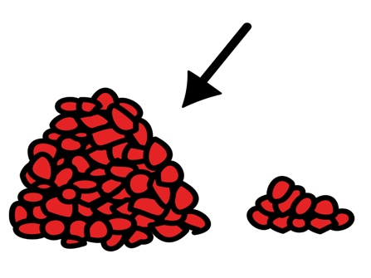 | Help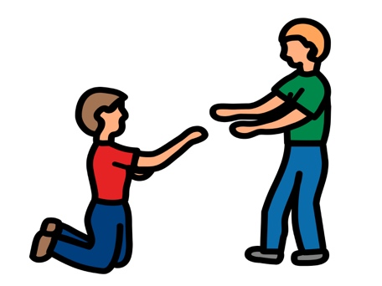 | Many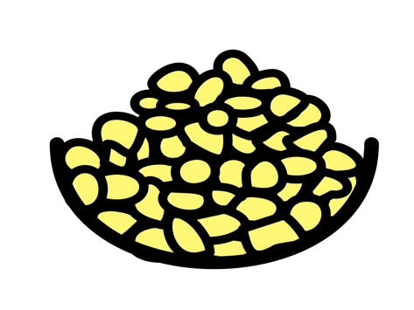
Stop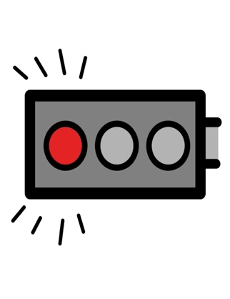 | Go | Push
*”Adaptations” adapted from: Haugen’s Modes for Adapting Toys based on materials from the "Let's Play" Project at the University of Buffalo
PCS is a trademark of Tobii Dynavox, LLC. All rights reserved. Used with permission.

